EXPERIMENT 1 .
- AIM:
To acquire data from multiple sources and perform data profiling using Microsoft Power BI in order to assess data quality, understand data structure, identify anomalies, and prepare data for further analytical processing.

- OBJECTIVES:
- To understand the basic concepts of Business Intelligence and data acquisition.
- To acquire data from multiple heterogeneous sources such as CSV, Excel, and SQL Server.
- To import and integrate different datasets into Microsoft Power BI.

- TOOLS / SOFTWARE REQUIRED:
  - Microsoft Power BI Desktop
  - Sample datasets: Sales_Data.csv, Employee_DB.xlsx, and a sample SQL database

- DATASET USED: Sales_Data.csv, Employee_DB.xlsx, Transactions.sql

- THEORY:
- Business Intelligence (BI) refers to the technologies and processes used to collect, integrate, analyze, and present business data to generate meaningful insights and support better decision-making. Key components of BI include:
    - Data Sources: Databases, flat files, cloud storage, and APIs.
    - ETL Pipeline: Extracts, transforms, and loads data for processing.
    - Data Warehouse/Data Lake: Stores structured or unstructured data.
    - BI & Reporting Tools: Tools such as Microsoft Power BI for data transformation and visualization.
    - Analytics Layer: Supports descriptive, diagnostic, predictive, and prescriptive analytics.
  - Data Acquisition is the process of collecting and importing data from different sources into a common environment for processing. In Power BI, data can be acquired using the Get Data option from sources such as CSV, Excel, SQL Server, cloud services, and web-based sources.
  - Data Profiling involves examining a dataset to understand its structure, content, and quality before further analysis. It helps assess important data quality dimensions such as completeness, uniqueness, validity, consistency, accuracy, and timeliness.
  - Data Profiling in Power BI – Power Query Editor: Power BI provides built-in data profiling features through Power Query Editor:
    - Column Quality: Shows the percentage of valid, empty, and error values.
    - Column Distribution: Displays value frequency along with distinct and unique counts.
    - Column Profile: Provides detailed statistics such as minimum, maximum, mean, median, and standard deviation for selected columns.
- PROCEDURE:
Part A: Software Setup and Data Acquisition
Step 1: Install the required software.
    - Download and install Microsoft Power BI Desktop.
    - Download and install SQL Server and SQL Server Management Studio (SSMS).
    - Open SSMS and ensure the SQL Server instance is available for connecting the transaction database.
Step 2: Launch Power BI Desktop and import the CSV file.
Home > Get Data > Text/CSV
Browse to Sales_Data.csv > Load
Step 3: Import the Excel file.
Home > Get Data > Excel Workbook
Browse to Employee_DB.xlsx > Select the appropriate sheet > Load
Step 4: Connect to the SQL database and import the Transactions table.
Home > Get Data > SQL Server
Enter server name and database details > Select Transactions table > Load
Verify that all three data sources appear in the Data pane on the right-hand side of the Power BI . window.
Part B: Data Profiling in Power Query Editor
Step 5: Open Power Query Editor.
Home > Transform Data
Step 6: Enable data profiling features.
View tab > Tick Column Quality
View tab > Tick Column Distribution
View tab > Tick Column Profile
Select each column one at a time and observe the profiling statistics displayed below the data . preview grid.
Step 7: Record profiling observations.
For each column in each dataset, observe and record:
    - Data type and total row count.
    - Null/empty percentage from Column Quality.
    - Distinct and unique value counts from Column Distribution.
    - Minimum, maximum, mean, and standard deviation for numeric columns from Column Profile.
    - Any errors, mismatched data types, or unexpected values.
Part C: Identify and Document Data Quality Issues
Step 8: Identify data quality issues from the profiling results.
Check for common issues such as:
    - High null or empty values in important columns.
    - Columns containing only one unique value.
    - Numeric columns containing text values or incorrect data types.
    - Date values outside the expected range or future dates.
    - Duplicate records indicated by low uniqueness.
Step 9: Document the identified issues.
Record at least three data quality issues found during profiling and mention a suitable . . remediation action for each issue.

- RESULT
Data from multiple heterogeneous sources (CSV, Excel, and SQL database) was successfully acquired and imported into Microsoft Power BI Desktop. Data profiling was performed using the Power Query Editor's built-in tools — Column Quality, Column Distribution, and Column Profile. Key data quality dimensions including completeness, uniqueness, and validity were assessed across all datasets, and data quality issues were identified and documented for remediation prior to analysis.

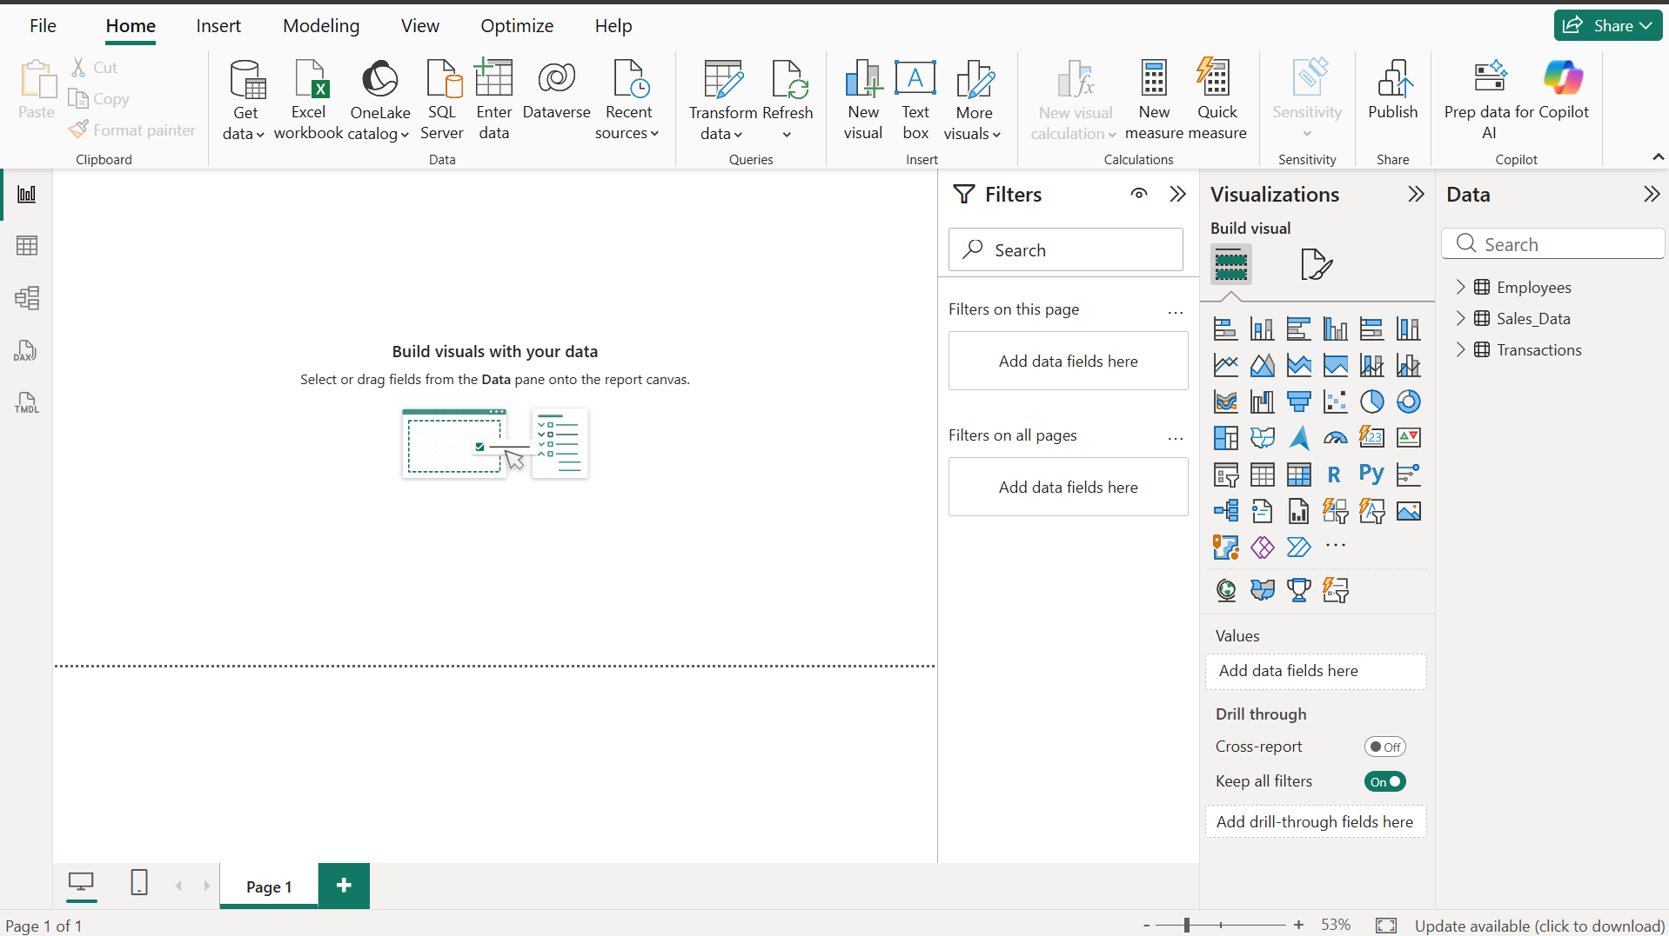
Fig 1.1: Power BI Dashboard

- LEARNING OUTCOMES
  - Understood the concept of Business Intelligence and its role in data-driven decision-making.
  - Learned how to acquire data from different heterogeneous sources.
  - Learned how to import CSV, Excel, and SQL Server data into Power BI.
  - Gained practical experience with Microsoft Power BI Desktop.
  - Learned how to use SQL Server Management Studio for working with SQL-based data.
  - Learned how to use Power Query Editor for data profiling.
  - Understood the purpose of Column Quality, Column Distribution, and Column Profile.
  - Learned how to identify missing values, duplicate records, data type mismatches, and other data quality issues.

